* ***Experiment 1:-***

***BREADBOARD & MULTIMETER***

***DIAGRAM***

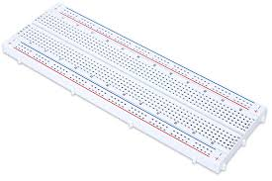Breadboard

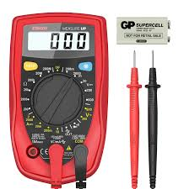 Multimeter

*Theory*

BREADBOARD:-

A breadboard is a solderless device for temporary prototype with electronics and test circuit designs. Most electronic components in electronic circuits can be interconnected by inserting their leads or terminals into the holes and then making connections through wires where appropriate. The breadboard has strips of metal underneath the board and connects the holes on the top of the board. The metal strips are laid out as shown below. Note that the top and bottom rows of holes are connected horizontally and split in the middle while the remaining holes are connected vertically.

TYPES OF BREADBOARD:-

There are two major types of breadboards; these are solder and solderless boards. Solder boards are boards you have to solder components onto (per the name). These are most of your standard circuit boards, and if you flip one over you’ll notice that all of the connections are soldered to the board itself. Solder-less breadboards are the one’s we’ve been focusing on. They make it easy to add or take off components as needed, and make circuit trial-and-error a lot easier. Both types of boards can be large, small… really any size.

MULTIMETER:-

A multimeter, also known as a **VOM** (volt-ohm-milliammeter), is an electronic measuring instrument that combines several measurement functions in one unit. A typical multimeter can measure voltage, current, and resistance. **Analog multimeters** use a microammeter with a moving pointer to display readings. **Digital multimeters** (DMM, DVOM) have a numeric display, and may also show a graphical bar representing the measured value. Digital multimeters are now far more common due to their lower cost and greater precision, but analog multimeters are still preferable in some cases, for example when monitoring a rapidly varying value.

A multimeter can be a hand-held device useful for basic fault finding and field service work, or a bench instrument which can measure to a very high degree of accuracy. Multimeters are available in a wide range of features and prices. Cheap multimeters can cost less than US$10, while laboratory-grade models with certified calibration can cost more than US$5,000.

Learning and Observations:

Observation:-

A **breadboard** is a platform you can **use** to build and test electronic circuits, usually without having to do any soldering. Certain parts of the **breadboard** are wired together so that electricity can flow from component to component in orderly rows.

*Precautions:*

1. Be certain the multimeter is switched to ac before attempting to measure ac circuits.
2. Always start with the highest voltage or current range.
3. Be certain to read ac measurements on the ac scale of a multimeter.

*Learning Outcomes:*

From this experiment we learn and acquire skills about:

1. Circuit can be made in a clean manner.
2. Multiple things can be checked using multi meter.